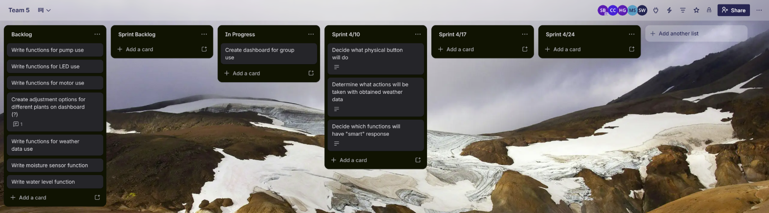
Week 1: We decided on a basic logical flow for the program, what inputs from the weather data will be factored into the device, and chose a function for the physical button on the flowerpot. We also started making the thingsboard dashboard. We had issues with sickness preventing some team members from coming in, and in figuring out a process to start hashing out the logic, but guidance from the professor helped us out. In this next week, we need to have a good portion of the individual checks and functions coded so we can start compiling them all into one master program.

